**Project Design Phase-II**

**Technology Stack (Architecture & Stack)**

|  |  |
| --- | --- |
| Date | 27 June, 2025 |
| Team ID | LTVIP2025TMID29337 |
| Project Name | Health AI : Intelligent HealthCare Assistant Using IBM Granite |
| Maximum Marks | 4 Marks |

**Technical Architecture:**

* The Web Interface is developed using Streamlit with Plotly for displaying health data charts.
* The backend is built with Python in the app.py file, handling user inputs and API calls.
* The AI responses for chat, disease prediction, and treatment plans come from IBM Granite LLM using IBM Watson ML API.
* API keys and sensitive information are stored securely using dotenv in a .env file.
* The application is deployed on Streamlit Cloud with environment variable support.

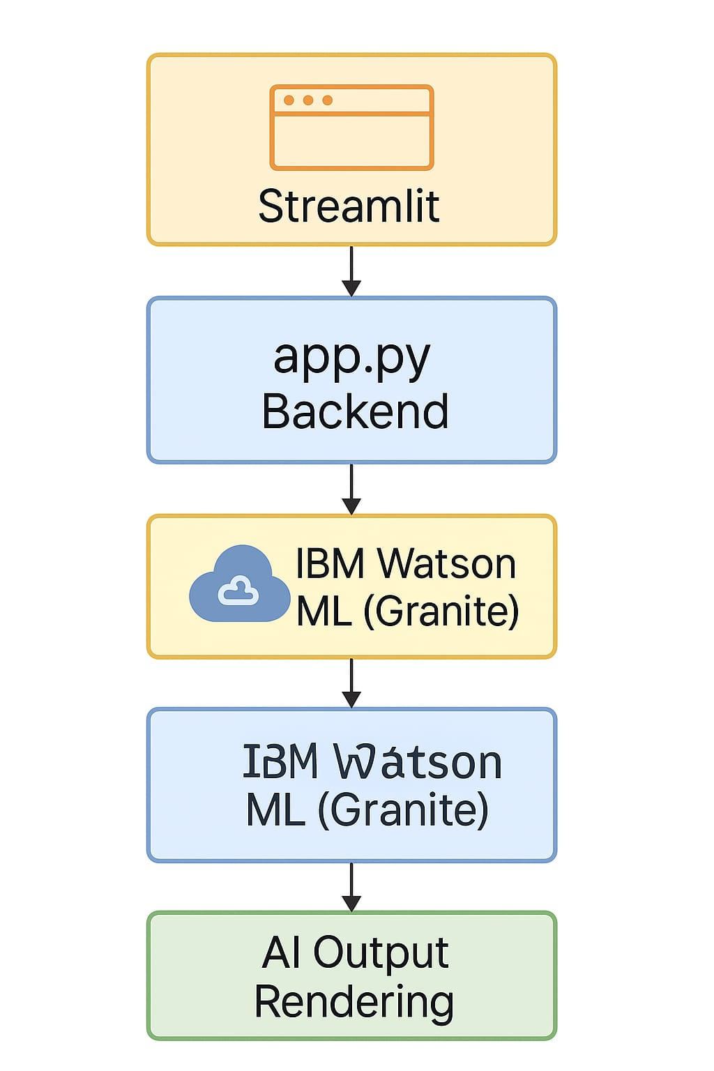

Guidelines:

Include all the processes (As an application logic / Technology Block)

Provide infrastructural demarcation (Local / Cloud)

Indicate external interfaces (third party API’s etc.)

Indicate Data Storage components / services

Indicate interface to machine learning models (if applicable)

**Table-1 : Components & Technologies:**

|  |  |  |  |
| --- | --- | --- | --- |
| **S.No** | **Component** | **Description** | **Technology** |
|  | User Interface | Web UI for patients (Chat, Disease Prediction, Treatment Plans, Health Analytics) | Streamlit, Custom CSS, Plotly |
|  | Application Logic-1 | Handle user inputs (Symptoms, Queries, Profile data) | Python (Streamlit app.py) |
|  | Application Logic-2 | Build prompts and handle API calls to IBM Granite | IBM Watson ML API (Granite LLM) |
|  | Application Logic-3 | Process AI responses for each module | Python Backend Logic |
|  | Health Data Visualization | Display patient metrics & trends. | Plotly + Streamlit UI Widgets. |
|  | Secure API Key Management | Store and load IBM API credentials securely | dotenv + Streamlit Secrets |
|  | |  | | --- | |  |  |  | | --- | | Cloud Hosting | | |  | | --- | |  |  |  | | --- | | Deployment and public access | | Streamlit Cloud |
|  | External API-1 | Connect to IBM Watson ML for AI Responses | IBM Watson Machine Learning API |
|  | Deployment Support | Runtime setup, package dependencies | requirements.txt, Streamlit CLI |
|  | Machine Learning Model | Language Model for Chat, Prediction, and Treatment generation | IBM Granite LLM via Watson ML |
|  | Infrastructure (Server / Cloud) | Hosting environment for app runtime and API communication | IBM Cloud / Streamlit Cloud. |

**Table-2: Application Characteristics:**

| **S.No** | **Characteristics** | **Description** | **Technology** |
| --- | --- | --- | --- |
|  | Open-Source Frameworks | Libraries & frameworks used for development | Streamlit, Python, Plotly, dotenv |
|  | Security Implementations | API key management, data privacy, environment security | HTTPS, dotenv, IBM Watson API Keys, SHA-256 (for any future user data storage security) |
|  | Scalable Architecture | Modular, extendable Streamlit app structure with external AI API integration | Streamlit Multipage App, IBM Watson ML APIs |
|  | Availability | Deployment on scalable and accessible cloud infrastructure | Replit, Streamlit Cloud |
|  | Performance | Fast AI response, API call optimization, minimal UI lag | Streamlit Caching, IBM Watson ML low-latency APIs |